**Thermodynamic assessment of Geothermal High-Temperature Heat Pumps for Industrial Steam Production**

P. Ungar1*, D. Fiaschi1, G. Manfrida1, L. Talluri1

1 Department of Industrial Engineering, University of Florence, Viale Morgagni 40-44, Florence, 50134

*\* Corresponding Author: pietro.ungar@unifi.it*

# Abstract

In recent years, the increasing awareness and pressing environmental issues have increased the urge to reduce the dependence of the industrial sector on natural gas. A clean and cost-efficient system capable of producing steam or medium-temperature heat (120-160°C) is therefore very appealing to the industrial sector. In this study, a new approach is proposed to produce steam at 10-15 bar based on mid-low temperature geothermal resources working with water or sCO2 heat pump systems. The main aim of the paper is to develop a simplified procedure to obtain preliminary screening results. The performance of the sCO2 system will be compared with a water loop for geothermal heat extraction coupled with a High-Temperature Heat Pump. From the results obtained, water-based systems are more promising than sCO2 cycles from a thermodynamic perspective. Indeed, CO2-based systems performances with the limited aim of heat extraction are not favorable solutions compared to water-based ones, due to the enthalpy gain, which is converted into pressure difference, which is suitable for an expansion but is not optimal for a heat upgrade configuration. Finally, the obtained results demonstrate how some of the assessed geothermal high-temperature heat pump configurations could achieve COP of over 3.

**Keywords**

Geothermal Energy, Heat Pump, supercritical CO2, thermodynamic, Borehole

# Introduction

Efficient production and distribution of renewable energy are crucial challenges in achieving the net-zero target by 2050. In 2021, heat production accounted for half of the world’s total energy consumption [1], with 51% of that demand stemming from industrial processes, which typically require heat temperatures above 80°C [2]. Furthermore, a 2019 study by the Oxford Institute for Energy Studies found that industrial processes needing heat in the range of 100°C to 500°C represent 30% of total industrial heat requirements, predominantly in sectors such as paper, printing, food, and chemicals [3]. High-temperature heat pumps (HTHP) are among the most promising technologies for decarbonizing industrial heat demand, leading to increased scientific interest in recent years.

##### High-Temperature Heat Pumps

Arpagaus et al. (2018) [4] conducted an extensive review of the current market and the state of the art of high-temperature heat pumps (HTHP), emphasizing the need for progressive development of HTHPs capable of delivering temperatures above 140°C. A detailed analysis of possible configurations for these applications was published by Zühlsdorf et al. in 2019 [5]. Their paper focuses on the production of steam for industrial applications, analyzing two different HTHP configurations that have been found to be competitive, in terms of levelized cost of heat, with other technologies. According to the authors, the most promising cycles for industrial steam production are a steam compression system and a supercritical CO2 (sCO2) reversed Brayton cycle. These cycles, slightly modified for integration with geothermal systems, are analyzed in this study.

As Arpagaus et al. [4] pointed out, the efficiency of an HTHP system is directly related to the source temperature, making the integration of a heat pump with a geothermal system highly beneficial in terms of energy consumption.

##### Geothermal Energy

Geothermal energy remains underutilized due to the need for specific geological conditions, such as the presence of a hot aquifer, for efficient resource extraction. One approach to overcoming this limitation is through the development of innovative well-construction techniques that could enable heat mining in a wider range of locations. When a hydrothermal resource is available, extracting hot water from a geothermal reservoir to a surface plant is one of the most efficient methods of utilizing geothermal energy. Alternatively, different strategies can be employed to extract heat from underground rock formations:

* *EGS systems*: The porosity of the target reservoir is increased by fracturing the rocks, allowing a working fluid to circulate and be heated by the surrounding rock formations [6], [7]. This technology enables high heat extraction rates due to the large heat transfer area between the fluid and rocks. However, the fracturing process has raised environmental and safety concerns, particularly in seismic regions, affecting social acceptance [8], [9]. Economic feasibility and scalability remain challenges that need further analysis.
* *Closed loop systems*: In these systems, the working fluid circulates in a closed-loop well and is heated during the process. While heat extraction rates are generally lower compared to EGS, safety concerns related to fracturing are eliminated. Scaling issues at the surface plant are also reduced. Economic feasibility remains a key concern, as a large number of wells are needed to increase the extraction rate. Various well geometries, such as U-shaped wells (sometimes referred as *advanced geothermal system* or *AGS*) or coaxial boreholes (referred in literature as *borehole heat exchangers* – *BHE*), have been proposed in the literature. Additionally, the repurposing of abandoned oil and gas wells has been explored. Closed-loop geothermal power plants offer significant technological potential due to their flexibility. This includes the ability to adjust the working fluid (from water to CO2 or customized mixtures), the intended output (heat, power, or cooling), and the operational strategy. Recently, the European HOCLOOP Project [10] was launched to experimentally study the heat transfer of geothermal fluids in a closed-loop system. If successful, this project could demonstrate a novel way to exploit geothermal energy, paving the way for further research on sustainable, enhanced heat transfer geothermal wells.

In this paper, the model for geothermal heat extraction has been generalized to assess the thermodynamic feasibility of the proposed coupling between industrial heat pumps and geothermal systems, independent of the specific geothermal technology used. The choice between different extraction technologies will become more relevant in future studies, particularly when considering the economic feasibility of the system.

##### Geothermal Working Fluid

Traditionally, water has been the primary working fluid for heat extraction from geothermal reservoirs. However, in recent decades, many researchers have begun exploring the use of CO2 in Enhanced Geothermal Systems (EGS) [11]–[13]. Compared to water, CO2 offers several advantages for heat extraction, including lower viscosity [13] and an enhanced thermosiphon effect in geothermal systems [12]. Additionally, the lower solubility of salts in CO2 can significantly reduce scaling issues typical of water-based systems and in some cases its usage can contribute to substantial carbon sequestration. However, water has a much higher heat capacity, which can lead to greater heat extraction rates.

Initially, the use of CO2 was primarily considered for EGS systems, as many of its advantages—such as low solubility and the sequestration effect—are less relevant in closed-loop systems, where there is no interaction between the fluid and reservoir rocks. Nevertheless, recent studies have also proposed the use of CO2 in closed-loop systems [14].

Recently, many researchers have begun comparing the advantages of using CO2 for combined heat and power generation by adopting a coupled approach that integrates both reservoir and surface equipment modeling [15], [16]. In this regard, a significant advantage of CO2 is that its natural pressurization enables direct power extraction through a turbine without the need for additional mechanical pumping.

##### Analyzed Configurations

The performance of CO2-based and water-based systems (depicted in *Figure 1*) has been compared with the aim of producing industrial steam from mid- to low-temperature geothermal resources. The configurations described are adaptations of the schemes presented in the work by Zühlsdorf et al. [5], modified for geothermal applications.

For the CO2-based configurations (*Figures 1.a*), the supercritical CO2 (sCO2) pressurized and heated by the geothermal well can be further compressed to enable high-temperature heat generation. After the heat exchanger, the sCO2 is expanded to improve process efficiency. Part of the power required by the heat pump can be generated by expanding a bleed from the main sCO2 flow exploiting the natural pressurization of the fluid.

For the water-based systems, the heated water can either be used to supply a high-temperature ORC (Organic Rankine Cycle) heat pump, which then generates steam in an ORC condenser or desuperheater *(Figure 1.b*), or it can be directly flashed to produce steam, which is then compressed to the desired conditions (*Figure 1.c*).

##### Novelty of the Study and Research Questions

After this introduction, a clear gap in the literature emerges. Geothermal energy has predominantly been considered as a heat source for heat pumps in residential applications, typically requiring only shallow wells. However, to the author’s knowledge, only one conference paper addresses the use of mid-enthalpy geothermal heat for industrial heat pumps, with a primary focus on the selection of the working fluid for high-temperature heat pumps (HTHP) [].

The aim of this work is to provide a comprehensive perspective on the coupling between geothermal reservoirs and various potential HTHP systems for industrial steam production, offering future developers a clear pathway for the design and implementation of such systems. In this context, the use of a simplified geothermal model is intended to provide a broader perspective without focusing on specific geothermal extraction technologies (e.g., EGS, BHE) or geological conditions.

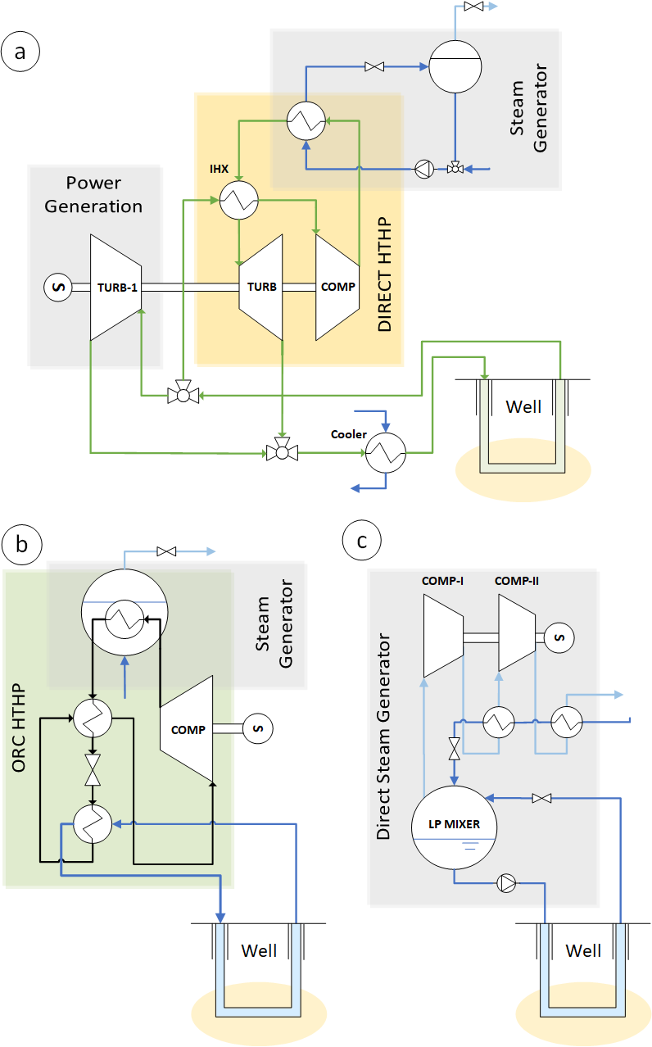

*Figure 1 – Proposed HTHP schemes: a) sCO2-based high temperature heat pump b) Indirect ORC heat pump fueled by the water circulating in the well c) direct steam generation. The depicted well is an AGS but the heat pump can any technology for extracting the geothermal heat can be considered.*

# Methodology

## Overall Model

The models for each system depicted in *Figure 1*, along with the one of the geothermal systems*,* were developed independently and subsequently coupled in Python. The thermodynamic properties of the working fluids (water and CO2) were obtained using REFPROP 10.0 [17], which was interfaced with Python through a custom-built connection. The following sections will provide a detailed description of each system model.

## Geothermal System Model

In this work, the geothermal system model was simplified to minimize the number of parameters to be selected or optimized, thereby generalizing the results and accelerating calculations. A schematic of the model is presented in *Figure 2*. The model consists of an upward and a downward section (0-1 and 2-3 in *Figure 2*), both assumed to be completely insulated from the surrounding ground and from each other. The *heat exchange section* (1-2) is where heat is transferred from the surrounding rocks to the working fluid. This transfer is assumed to occur at constant pressure and depth.



Figure 2 – Well Model Schemes: On the left is the overall model scheme. On the right is the scheme of one of the possible heat exchange sections, in this case modeling a coaxial borehole heat exchanger.

To make the model as general as possible, any reference to the well geometry has been eliminated. To do so the following additional assumptions have been utilized:

* In *ascending* and *descending* sections **pressure losses have been neglected** as the gravitational contribution is usually by far the most important term of the pressure gradient [12]
* The *heat exchange section* has beenmodeled defining a correlation between **pressure and temperature at the outlet**

As a result, the model just described relies only on the 4 parameters listed in the table below:

**Table 2.**  Geothermal system model parameters

|  |  |  |
| --- | --- | --- |
| **Parameter** | **Description** | **Units** |
| $$Depth$$ | Depth of the *heat exchange section* of the system (and hence the length of the ascending and descending sections) | m |
| $$T_{rocks}$$ | The undisturbed temperature of the rock in the surroundings of the *heat exchange section* | °C |
| $${∆T}_{HE}$$ | Difference between the fluid temperature and the undisturbed rock temperature at the outlet of the *heat exchange section* | °C |
| $${∆P}_{HE}$$ | Pressure losses in the *heat exchange section* | bar |

Following the standard approach described by Di Pippo [12], the ascending and descending sections can be modelled as follows:

|  |  |
| --- | --- |
| $∆s= 0$ | (2.1) |
| $$∆h=-gΔz$$ | (2.2) |

This allow to evaluate the overall section in one step under the assumption of adiabaticity of the well as discussed earlier. Similarly, the *heat exchange section* can be easily modelled using ${∆T}_{HE}$ and ${∆P}_{HE}$, Eqns. 2.3-2.4.

|  |  |
| --- | --- |
| $P_{2}= P_{1}- {∆P}_{HE}$ | (2.3) |
| $$T_{2}= T_{rock}- {∆T}_{HE}$$ | (2.4) |

The described model can predict the thermodynamic behavior of every closed-loop geothermal system well (EGS, BHE, U-tubes, etc.) by simply changing the correlation for ${∆T}_{HE}$ and ${∆P}_{HE}$*.* These two parameters are to be selected in the design phase of the heat pump plant optimizing the geometry of the well depending on the specific reservoir conditions.

For example, in an EGS model ${∆T}_{HE}$ can be set to zero while ${∆P}_{HE}$ evaluated using a reservoir permeability correlation as in [18]. On the other hand, for BHE systems ${∆P}_{HE}$ and ${∆T}_{HE}$ evaluated considering the length of the section as shown in figure 2.

The choice of a simplified model allows for the characterization of the expected outcome from the geothermal well coupled with an HTHP, without the need for a complete description of the geometry or a detailed geological analysis, which could have limited the validity of our findings to a specific case study. In this framework, the results presented in this paper should be interpreted as representing the best achievable conditions for a geothermal well, given the specified depth and temperature. For future developers, this analysis can be easily updated to assess the real system feasibility using a more detailed well model tailored and optimized for a specific location.

## Surface Plant Models

The model for the various surface plant configurations proposed in this article was developed in Python. The steam generation units are designed to produce saturated steam at **12 barg (191.60°C)**, which is a typical value for steam circuits in papermills [22]. Each configuration has some specific optimization parameters, which will be identified in the system's description and optimized using the procedure described above.

##### sCO2 high temperature heat pump (fig 1.a)

The hot and pressurized CO2 that is extracted from the geothermal system is splitted with some of the flow being directed to the main turbine (TURB-1) and the rest being directed to the heat pump section. The ratio between the flow rates is defined according to the parameter ${sep}_{\%}$:

|  |  |
| --- | --- |
| $${sep}_{\%}= \frac{{\dot{m}}_{TURB-1}}{{\dot{m}}_{{sC0}_{2}}}$$ | (3.1) |

In the heat pump section, a steam drum arrangement, as shown in *Figure 4*, was selected for the steam generation section. This configuration is more practical than a typical shell-and-tube heat exchanger, given the high pressure expected on the sCO2 side. The mass ratio between sCO2 and water in the heat exchanger was chosen to maximize heat transfer efficiency by coupling the heat capacities of the fluids:

|  |  |
| --- | --- |
| $${\dot{m}}_{water ratio}= \frac{{\dot{m}}_{{sC0}_{2}}}{{\dot{m}}_{water}}= \frac{{{c_{p}}_{{sC0}_{2}}}_{mean}}{{c_{p}}_{water}}$$ | (3.2) |

In the water side of the heat exchanger, to prevent water vaporization into the heat exchanger itself. After the heat exchanger, the hot water is expanded in a valve to reach the pressure of the steam drum. The ratio between the flow of steam generated and the flow of CO2 that has to be circulated into the well (called ${\dot{m}}_{ratio}$) can be then immediately calculated considering the resulting vapour quality after the expansion ($x_{exp}$) and the amount of CO2 that is directed to TURB-1 (${sep}_{\%}$):

|  |  |
| --- | --- |
| $${\dot{m}}_{ratio}= \frac{{\dot{m}}_{steam}}{{\dot{m}}_{{sC0}_{2}}}= \frac{x_{exp} {\dot{m}}_{water}}{{\dot{m}}_{{sC0}_{2}}}\left(1-{sep}_{\%}\right)= \frac{x_{exp} \left(1-{sep}_{\%}\right)}{{\dot{m}}_{water ratio}}$$ | (3.3) |

After the heat exchanger, the sCO2 is expanded to recover part of the compressor power and cooled to increase its density and to maximize the thermosyphon effect generated by the well.



Figure 4 - Schematics of the HTHP steam generation system on a TH diagram. sCO2 transformation in green, water/steam transformation in blue. The enthalpy scale refers to water, the sCO2 enthalpy scale has been modified so that ${Δh}_{{sCO}_{2}}= {Δh}_{H_{2}O}$ in the heat exchanger for better visualization.

The optimization parameter for the system are the maximum temperature of the sCO2 cycle ( $T_{{CO}_{2} max}$- inlet of the heat exchanger) and the amount of CO2 flowing into the main turbine (${sep}_{\%}$). Some fixed parameters were assumed in the model for both CO2-based configurations. They are listed in the table below:

**Table 4.** CO2-based systems (1.a and 1.b) Fixed Parameters

|  |  |  |
| --- | --- | --- |
| **Symbol** | **Description** | **Value** |
|  | sCO2 Compressor Efficiency | 0.8 |
|  | sCO2 Expander Efficiency | 0.75 |
| $$η_{pump}$$ | Water pump efficiency | 0.8 |
| $${ΔT}_{HE}$$ | Temperature difference between water and sCO2 in the heat exchanger | 8 °C |
| $$T_{0}$$ | Temperature at the inlet of the well | 10 °C |

##### Standard heat pump connected to the well water circuit (fig 1.b)

This configuration uses water as the working fluid in the geothermal well. The heated water is used to feed the evaporator of a conventional regenerative heat pump. Steam is generated in the heat pump's condenser, which is considered as a shell-and-tube heat exchanger with the steam evaporating in the shell. The condensation temperature is evaluated assuming a ΔTpp relative to the steam. The evaporator is considered a shell-and tube as well with the water heated in the geothermal well running inside the tubes. Various working fluids have been tested for the high-temperature heat pump (HTHP) to identify the one that best meets the system's requirements. The main optimization parameter is the temperature range of the water in the HP evaporator ( ${Range}_{EVA}$ in figure 5). The regenerator efficiency has been set to 0.5. Other fixed parameters, shared with System 1.d, are listed in Table 5.

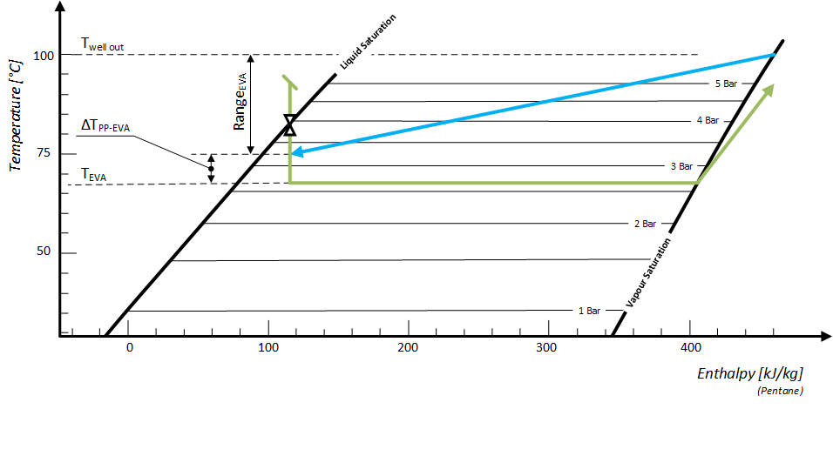

Figure 5 - Schematics of the temperature profile in the HP evaporator. HP working fluid (n-pentane in this case) in green, geothermal water in blue. The enthalpy scale and the saturation lines refer to n-pentane, the water enthalpy scale has been modified so that ${Δh}_{pentane}= {Δh}_{H_{2}O}$ in the heat exchanger for better visualization.

##### Direct compression of steam generated by the well water flash (fig 1.d)

In this configuration, the hot water extracted from the well is flashed through a valve into a steam cylinder. The generated steam is then compressed to reach the target pressure and temperature values required by the industrial process. A multistage compression process with intercooling is proposed to enhance efficiency, with each intercooler being cooled by the saturated liquid returning from the plant.

The saturation temperature inside the cylinder ($T_{GC}$) is determined during the optimization process. The following table lists the fixed parameters used for system modeling.

**Table 5.**  Water-based systems (1.c and 1.d) Fixed Parameters

|  |  |  |
| --- | --- | --- |
| **Symbol** | **Description** | **Value** |
| $$η_{comp}$$ | Compressors/Pumps Efficiency | 0.8 |
| $${ΔT}_{PP}$$ | Heat exchangers pinch points | 10 °C |

## Overall Optimization of the system

The simplicity of the well model described allows for direct optimization of the overall system, optimizing both the well and surface installation parameters simultaneously. The optimization process targets two distinct objectives, both to be – ideally – **maximized**, as shown in Table 3.

**Table 3.**  BHE Optimization Objectives

|  |  |
| --- | --- |
| **Parameter** | **Comment** |
| $${\dot{W}}_{net rel} := \frac{{\dot{W}}_{net}}{{\dot{Q}}_{steam}}$$ | ${\dot{Q}}_{steam}$ is the heat provided to the generated steam and ${\dot{W}}_{net}$ is the net *electrical* power balance of the heat pump, negative when the heat pump requires power. Note that ${\dot{W}}_{net rel}= {-1}/{COP}$ (the heat pump *coefficient of performance*) |
| $${\dot{m}}_{ratio} := \frac{{\dot{m}}_{steam}}{{\dot{m}}_{BHE}}$$ | ${\dot{m}}_{steam}$ and ${\dot{m}}_{BHE}$ are respectively the flow rate of steam and the flow rate of the fluid circulated in the well. |

Where ${\dot{W}}_{net rel}$ has been chosen instead of the COP as in some (extreme) condition the CO2-based system can be used for cogeneration creating some numerical instabilities as the COP becomes infinite with ${\dot{W}}_{net}=0$. These parameters are interesting as ${\dot{W}}_{net rel}$ is related to the OPEX (Operational Expenditure) of the plant, while ${\dot{m}}_{ratio}$ mainly affects the CAPEX (Capital Expenditure). This is because electrical consumption is typically the largest contributor to operating costs, while well drilling has a significant impact on capital investment, often accounting for about 60% of the total cost [21]. In fact, ${\dot{m}}_{ratio}$ influences the size and number of wells needed. A higher mass flow rate requires either drilling more wells or constructing larger ones, both of which increase capital costs. Therefore, what has been just presented mimic essentially an economic optimization, balancing operating and capital costs, even though it is achieved through a maximization of two thermodynamic parameters. Practically, the optimization is performed by maximizing $x_{min}$, as defined in Eq. 2.5, to balance both operating and capital costs.

|  |  |
| --- | --- |
| $$x_{min}= \left(1- Ω\right)\log\left({\dot{W}}_{net rel}+1\right)+Ω log\left({\dot{m}}_{ratio}\right)$$ | (2.5) |

The parameter $Ω$ determines the relative importance of ${\dot{m}}_{ratio}$ and ${\dot{W}}_{net rel}$ in the optimization process, thereby controlling the balance between CAPEX and OPEX.

Decreasing $Ω$ steers the solution toward reducing OPEX by prioritizing the optimization of ${\dot{W}}_{net rel}$ (the $COP$), which improves operational efficiency and reduces electricity consumption. This approach is suitable when operational costs, such as energy prices, are a primary concern. Conversely, increasing $Ω$ places more emphasis on reducing CAPEX by focusing on maximizing ${\dot{m}}_{ratio}$, which affects the size and number of wells required, thus lowering upfront capital costs.

Ultimately, the choice of $Ω$ will depend on the specific conditions of the real installation and may vary based on factors such as resource availability, energy prices, and the expected lifetime of the project. The flexibility provided by $Ω$ allows for the analysis of various scenarios without requiring detailed information about the well geometry or the geological setting. This approach enables a more generalized form of optimization, allowing for an economic assessment that is not constrained by the specifics of a particular case study. However, for a true economic optimization, the analysis would need to be tailored to the specific characteristics and constraints of the actual installation.

##### Remarks on the Pareto-front optimization

The proposed approach is equivalent to identifying the pareto frontier and the selecting a specific point on it using $Ω$ as a weighting factor. The optimal point identified by Equation 2.5 is guaranteed to lie on the Pareto frontier as long as $Ω>0$. This is because, by definition of the pareto front, if a point $x$ is not part of the frontier, there should be another point $x^{*}$ so that:

|  |  |
| --- | --- |
| $${\dot{m}}_{ratio}\left(x\right)< {\dot{m}}_{ratio}\left(x^{*}\right) ∧{\dot{W}}_{net rel}\left(x\right)< {\dot{W}}_{net rel}\left(x^{*}\right)$$ | (2.6) |

But if that is the case, $x_{min}\left(x\right)< x_{min}\left(x^{*}\right)$, hence $x$ is not a maximum of *Equation 2.5*. Maximizing Equation 2.5 is a more convenient approach compared to identifying the entire Pareto frontier and then selecting a point from it. This is why that approach has been chosen.

##### Remarks on a multi-parameter optimization

The above statement holds for optimization processes that focus on a single variable, as the one that has been defined for the water-based scenario. However, in multi-parameter optimization, a Pareto-optimal point can correspond to a saddle point for $x_{min}$ (minimum with respect to one parameter and maximum with respect to another). This implies that simply identifying the location where $x_{min}$ is minimized may not be sufficient to determine the true point on the Pareto frontier. Instead, the correct point must be located by finding where:

|  |  |
| --- | --- |
|  | (2.7) |

Or where $\left|{∇x}_{min}\right|$ is minimum (as $\left|{∇x}_{min}\right|$ is always $≥0$). This is clarified in Figures 6 and 7 for the CO2-based scenario. In fact, from Figure 6 it is clear that an optimal condition has to exists somewhere as ${\dot{W}}_{net rel}$ and ${\dot{m}}_{ratio}$ shown opposite trends. To validate the minimization approach in this specific condition (*800m depth well and 90°C rock temperature*) we have evaluated the complete pareto frontier - shown as blue dots in Figure 7 on the right. In this case directly minimizing $x_{min}$ as defined in Eq. 2.5 will unfortunately identify a condition that is not part of the pareto front (red mark in Figure 7 on the left). This is because the actual point on the pareto front correspond to a saddle point for $x_{min}$ (yellow star in Figure 7 on the left). The correct results for different values of $Ω$ (Black line in Figure 7 on the right) are obtaining minimizing $\left|{∇x}_{min}\right|$ as defined in Eq. 2.5. It is interesting to notice that in these condition for values of $Ω>0.45$ the optimization is completely dominated by the OPEX side selecting the condition where ${\dot{W}}_{net rel}$ is higher regardless of the decrease in ${\dot{m}}_{ratio}$. On the other side for $Ω<0.2$ the opposite is true and the optimizer select the condition with higher ${\dot{m}}_{ratio}$ in any case.

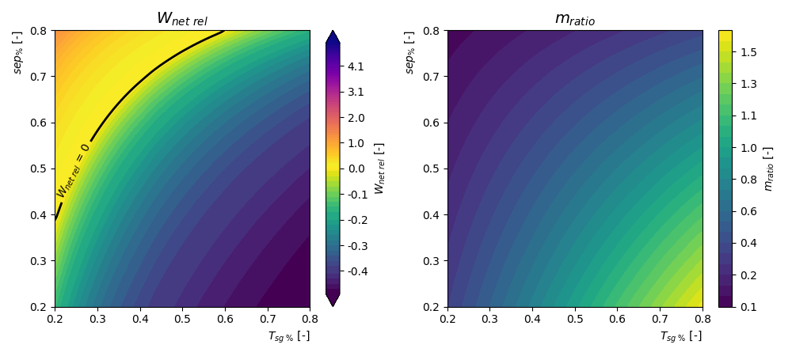

Figure 6 – Wnet rel and mratio for a CO2-based HTHP varying sep% and Tsg %. From the graph it is clear that Wnet rel increase for lower values of Tsg % and higher values of sep% while the opposite is true for mratio. Hence is reasonable to expect that different optimization point will be obtained for different values of Ω.

# C:\Users\Utente\PycharmProjects\BHEModel2.0\calculation\0 - Older Calculations\2022-10-04 - HTHP\new calculations\00 - Output\CO2-optimization (800m-100C-km).png

Figure 7 – On the right: Results obtained by optimizing xmin following the approach shown in Eq. 2.7 (dark line) for different value of Ω compared with the real pareto front points (blue dots). From the image on the left is clear that the optimal solution for Ω=0.3 is a saddle point (yellow star) and that simply maximising xmin would have identified the condition (sep% = 0.8, Tsg % = 0.2 - red cross) as an optimal solution. Which is not correct though as that condition is not part of the pareto point.

# Results

## Remarks on the importance of an Internal Heat Exchanger

CO2-based systems are known for their extreme pressurization and the HTHP proposed in this work is not an exception.

##### C:\Users\Utente\PycharmProjects\BHEModel2.0\calculation\0 - Older Calculations\2022-10-04 - HTHP\new calculations\00 - Output\max pressure comparison.png

~~Figure 6 shows the trends of the $COP$ and the ${\dot{m}}_{ratio}$ for the four case studies, varying the main optimization parameters for a well depth of 800m and a rock temperature of 90°C. For both the direct sCO~~~~2~~ ~~heat pump and the direct steam generation systems, dimensionless optimization parameters (as shown in Table 6) were used. This reflects the fact that the optimization parameters are bounded between two limiting values.~~

**~~Table 6.~~** ~~Adimensional Optimization Parameters~~

|  |  |  |  |
| --- | --- | --- | --- |
| **~~Configuration~~** | **~~Equation~~** |  |  |
| *~~direct sCO~~~~2~~ ~~heat pump (fig 1.a)~~* |  |  |  |
| *~~direct steam generation (fig 1.d)~~* |  |  |  |

~~For the~~ *~~direct sCO~~~~2~~ ~~heat pump~~* ~~is the temperature that can be reached by compressing the CO~~~~2~~ ~~to the maximum pressure allowable in the cycle (arbitrarily chosen to be 500 bar). On the other hand, for the~~ *~~direct steam~~* ~~configuration the minimum temperature has been set to 10°C to avoid a possible issue with ice formation in the steam generator.~~

~~As can be seen from Fig. 6a, an increase in the value of $T_{SG\%}$ implies an increase in both the $COP$ and the ${\dot{m}}_{ratio}$. The increase of both parameters means that there is no clear minimum for $x_{min}$, in this specific geological condition and the performance of the configuration is limited by the maximum pressure level in the cycle.~~

~~For the~~ *~~direct steam generation~~* ~~and the~~ *~~indirect heat pumps,~~* ~~on the other hand, it can be noted that the $COP$ and the ${\dot{m}}_{ratio}$ have different behaviors. This means that an optimum could be found in the optimization process (the exact position of the optimum will depend on the selected value for ).~~

~~Is interesting to notice that, for water-based systems, $COP$ and ${\dot{m}}_{ratio}$ are mathematically related in a way that assured them to have opposite trends. Starting from the energy conservation of the heat whole system it can be found that:~~

|  |  |
| --- | --- |
|  | ~~(4.1)~~ |

~~Rearranging:~~

|  |  |
| --- | --- |
|  | ~~(4.2)~~ |

~~Were ${Δh}_{ratio}= {{Δh}_{steam}}/{{Δh}_{BHE}}$ does not depend on the surface plant configuration. Taking the derivative of eq. 4.2:~~

|  |  |
| --- | --- |
|  | ~~(4.3)~~ |

~~From equation 4.3 is clear that ${d{\dot{m}}_{ratio}}/{dCOP}$ is negative if ${Δh}_{ratio}$ is positive. What was obtained for water-based systems is not valid for the CO~~~~2~~~~-based ones as the presence of a cooler that discharges part of the heat to enhance the thermosyphon effect makes eq. 4.1 untrue.~~

~~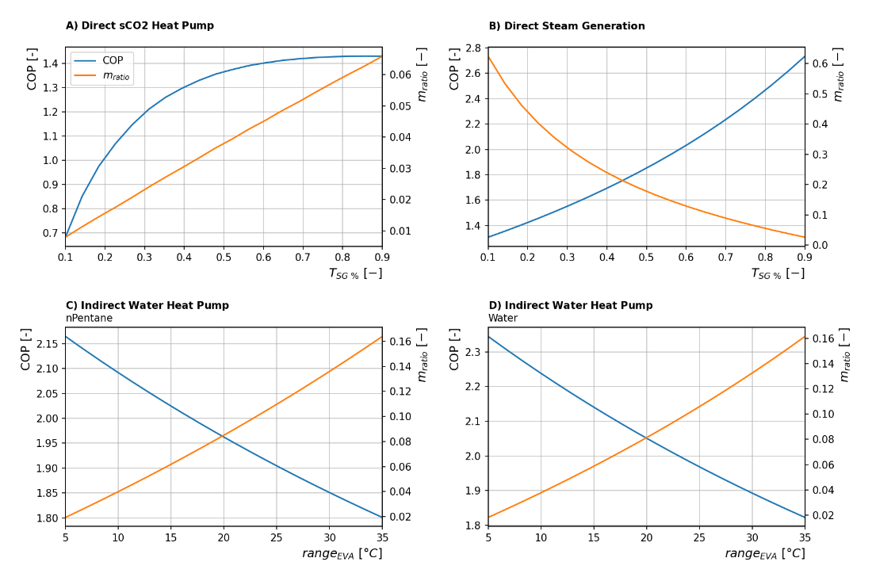~~

~~Figure 6 – COP and m~~~~ratio~~ ~~for different system configurations considering an~~ ~~800m depth well and 90°C rock temperature: A) sCO~~~~2~~ ~~direct HTHP powered by an electric motor (figure 1.a). B) Direct Water HTHP (figure 1.c). C) Indirect ORC heat pump with n-Pentane as ORC fluid (figure 1.b). D) Indirect ORC heat pump with Water as ORC fluid (figure 1.b).~~

## Standalone sCO2 HTHP behavior

Figure 7 shows the behavior of the standalone sCO2 system for the same conditions considered for the other systems *(800m depth well and 90°C rock temperature)*. Density was used instead of pressure in optimizing the input condition of the BHE for stability reasons, but the two parameters are related. A clear optimum can be identified for ${\dot{m}}_{ratio}$ for ${rho}_{in}≈600 kg/m^{3}$. Unfortunately for this configuration the expected ${\dot{m}}_{ratio}$ is extremely low even at the optimum. Table 7 displays the expected values of flow rates needed in the well to produce 1kg/s of steam, for the sake of clarity.

**Table 7.**  Well flow rate to produce 1kg/s of steam in optimal condition

(800m depth well and 90°C rock temperature)

|  |  |
| --- | --- |
| **Configuration** | **Well Flow Rate** |
| *Direct sCO2 heat pump (fig 1.a)* | 16.7 kg/s |
| *Standalone sCO2 heat pump (fig 1.b)* | 220 kg/s |
| *Indirect ORC heat pump (fig 1.c)* | 3.6 kg/s |
| *Direct steam generation (fig 1.d)* | 4.8 kg/s |

The huge amount of fluid that must be circulated is mainly caused by the LP turbine which needs more than 90% of the overall flow to drive the HTHP in the optimal condition *(right-hand side of figure 7)*. This makes this configuration extremely impractical and surely uneconomical as it will probably require a great number of wells to handle the expected flow rate. For this reason, this configuration was excluded from the analysis presented in the following paragraphs.

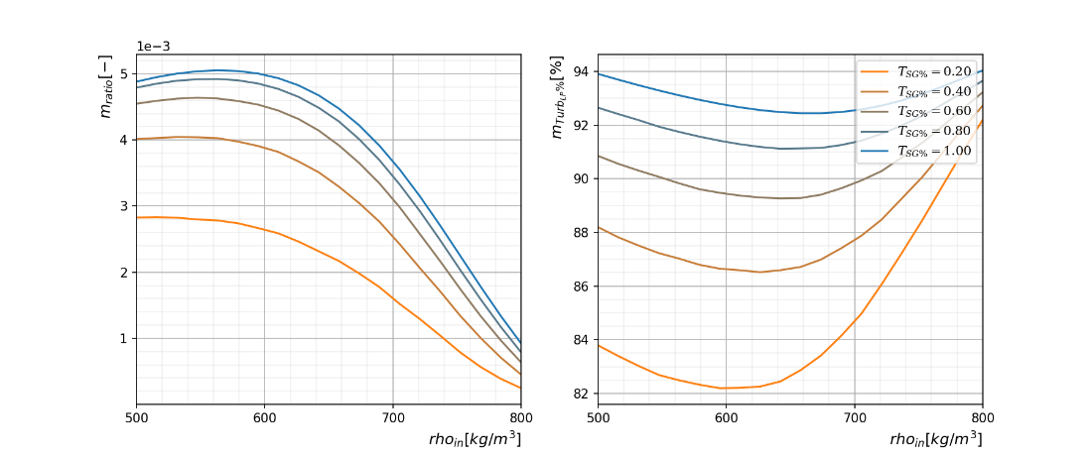

Figure 7 – ${\dot{m}}_{ratio}$ and ${\dot{m}}_{{Turb }_{LP} \%}$ relation with $ρ_{in}$ and $T_{SG\%}$ for standalone sCO2 configuration considering an 800m depth well and 90°C rock temperature: A) sCO2 direct HTHP powered by an electric motor (figure 1.a). B) Direct Water HTHP (figure 1.c). C) Indirect ORC heat pump with n-Pentane as ORC fluid (figure 1.b). D) Indirect ORC heat pump with Water as ORC fluid (figure 1.b).

## Configuration Comparison

Figure 8 resumes the effect of the optimization parameter $Ω$ on the assessed configurations at different rock temperatures. In the figure, different depth levels are not represented for the water-based BHE system as the impact of depth variation is negligible because of water incompressibility (clear from figure 9). For the sCO2 heat pump configuration depths from 500 to 3000 m have been assessed.

The graph shows that the *direct sCO2 heat pump* is not affected $Ω$ by the optimization process: this happens because in most cases, as shown in figure 6.a, it is not possible to find a real maximum, and the performance is limited by the maximum pressure allowable in the system. On the other hand, water-based systems are affected by a $Ω$ variation exactly as expected ( $COP$ increase for higher $Ω$ while ${\dot{m}}_{ratio}$ decrease).

As expected, an increase in rock temperature is beneficial for all systems from a $COP$ point of view, while it has different effects on the ${\dot{m}}_{ratio}$ (due to the relation between $COP$ and ${\dot{m}}_{ratio}$ discussed before). On the other hand, for sCO2 systems, an increase in depth implies a reduction in performance for the same rock temperature because the CO2 expands and cools down while rising in the well hence a higher depth result in a lower temperature at the surface.

For almost all assessed cases, the best $COP$ is reached for the *direct Water* *configuration* when the rock temperature is above 100°C, while for lower temperatures the *indirect configurations* perform better.



Figure 8 – Effect of $Ω$ on the optimization process for different rocks temperature and well depth.

## Depth-Trocks maps

Figures 9 and 10 provide sensitivity analyses of the $COP$ and ${\dot{m}}_{ratio}$ variation as a function of depth and rock temperature. As can be seen for the water-based configurations there is almost independence from the depth, while for the direct sCO2 configuration, the depth is a key variable. This is due to the compressibility of the fluid, which is an impacting factor for CO2, while it is not relevant for water. An increase in depth allows an increase in the pressure difference, and therefore a favorable thermosiphon condition and a reduction of the available heat. Indeed, in this case, the enthalpy gain is converted into pressure difference, which is suitable for an expansion but is not optimal for a heat upgrade configuration. These results have been obtained by optimizing eq. 2.5 with Ω=1.

It is very interesting to note the very high value of $COP$ which can be reached with these configurations. Particularly, with the direct steam generation, $COP$ of over 3.5 can be obtained with a resource temperature of 90°C. For the sCO2 heat pump, on the other hand, a maximum come of over 2 is reachable.

In figure 10 isoline contour has been identified with a fraction to make the ratio readings easier, for example, *1/100* means that to produce 1kg/s of steam 100kg/s of CO2 must be circulated in the well.

Finally, Figure 11 shows how these maps can be used to estimate the behavior of a geothermal HTHP given the geological condition of the selected location. In fact, by superimposing real geothermal gradients [23]–[27] to the graph is possible to identify the expected value of $COP$ and ${\dot{m}}_{ratio}$ that can be achieved for different depths. For example, a *direct sCO2 heat pump* installed in the location related to gradient d.1 (southern Tuscany) could have a maximum $COP=1$ for a 1500 m depth well while a *direct Water* plant installed in the same location could reach $COP$ as high as 2.2 considering the same well depth.



Figure 9 – COP relation with resource depth and temperature for different surface plant configurations



Figure 10 – mratio relation with resource depth and temperature for different surface plant configurations: A) sCO2 direct HTHP powered by an electric motor (figure 1.a). B) Direct Water HTHP (figure 1.c). C) Indirect ORC heat pump with nPentane as ORC fluid (figure 1.b). D) Indirect ORC heat pump with Water as ORC fluid (figure 1.b).



Figure 11 – Real geothermal gradients superimposed on estimated maximum COP from figure 8. Gradients a, b and c are mean and standard distribution from multiple exploration wells in: a) Absheron peninsula (Azerbaijan) and in Alberta (Canada) [23], [25], b) Netherlands [24], c) Daqing Oilfield, Northeast China [26]. Gradients d.1, d.2, d.3 and d.4 are well log from a south Tuscany geothermal field [27]

# Conclusions

A full design procedure for the prediction of the thermodynamic behavior of closed-loop geothermal system well configuration (EGS, BHE, U-tubes, etc.) used for high-temperature heat pump industrial heat production was carried out in this work, by the introduction of two correlation parameters ${∆T}_{HE}$ and ${∆P}_{HE}$*.* These two parameters are to be selected in the design phase of the heat pump industrial heat production system optimizing the geometry of the well depending on the specific reservoir conditions. A pivotal point of this research is the introduction of a generalized procedure: the proposed approach does not only consider the borehole heat exchanger but also includes different heat extraction configurations, from the sCO2 heat pump to standard water-type ones.

The key outcomes of the presented work have general validity and may be summarized as follows:

* This work shows multiple solutions to produce high-temperature steam (at 180°C) from a geothermal-fueled high-temperature heat pump. From the result obtained water-based systems are more promising than sCO2 cycles from a thermodynamic perspective.
* The maps plotted in figures 9 and 10 can be useful for designers to assess the potential of such systems given the existing geological condition.
* The thermodynamic performance of the water-based configurations is promising and encourages the development of a thermo-economic analysis to assess the feasibility of the solution.
* CO2-based systems performances with the limit of heat extraction are not feasible solutions, especially for a standalone system. This is because the enthalpy gain is converted into pressure difference, which is suitable for an expansion but is not optimal for a heat upgrade configuration.

As a final remark, the analysis here perfumed showed how the expected COP values of the proposed configuration are quite attractive, as state-of-the-art technology struggles to achieve a cop of 2 for a steam production temperature of 180°C, while some assessed configurations could achieve COP of over 3.5.

# References

[1] IEA, “Heating,” *IEA, Paris*, 2022. https://www.iea.org/reports/heating (accessed Jan. 20, 2023).

[2] IEA-IETS, “Application of Industrial Heat Pumps,” 2014.

[3] A. Honore, “Decarbonization and industrial demand for gas in Europe,” Oxford, United Kingdom, May 2019. doi: 10.26889/9781784671396.

[4] C. Arpagaus, F. Bless, M. Uhlmann, J. Schiffmann, and S. S. Bertsch, “High temperature heat pumps: Market overview, state of the art, research status, refrigerants, and application potentials,” *Energy*, vol. 152. Elsevier Ltd, pp. 985–1010, Jun. 01, 2018. doi: 10.1016/j.energy.2018.03.166.

[5] B. Zühlsdorf, F. Bühler, M. Bantle, and B. Elmegaard, “Analysis of technologies and potentials for heat pump-based process heat supply above 150 °C,” *Energy Conversion and Management: X*, vol. 2, p. 100011, Apr. 2019, doi: 10.1016/j.ecmx.2019.100011.

[6] S. Li, S. Wang, and H. Tang, “Stimulation mechanism and design of enhanced geothermal systems: A comprehensive review,” *Renewable and Sustainable Energy Reviews*, vol. 155, p. 111914, Mar. 2022, doi: 10.1016/j.rser.2021.111914.

[7] P. Olasolo, M. C. Juárez, M. P. Morales, S. Damico, and I. A. Liarte, “Enhanced geothermal systems (EGS): A review,” *Renewable and Sustainable Energy Reviews*, vol. 56. Elsevier Ltd, pp. 133–144, Apr. 01, 2016. doi: 10.1016/j.rser.2015.11.031.

[8] HOCLOOP, “"A circular by design environmentally friendly geothermal energy solution based on a horizontal closed loop”, Call Horizon-CL5-2021-D3-03, Project ID 101083558.”

[9] G. Cui, S. Ren, Z. Rui, J. Ezekiel, L. Zhang, and H. Wang, “The influence of complicated fluid-rock interactions on the geothermal exploitation in the CO2 plume geothermal system,” *Appl Energy*, vol. 227, pp. 49–63, Oct. 2018, doi: 10.1016/j.apenergy.2017.10.114.

[10] K. Pruess, “Enhanced geothermal systems (EGS) using CO2 as working fluid-A novel approach for generating renewable energy with simultaneous sequestration of carbon,” *Geothermics*, vol. 35, no. 4, pp. 351–367, Aug. 2006, doi: 10.1016/j.geothermics.2006.08.002.

[11] D. Brown, “A Hot Dry Rock Geothermal Energy Concept Utilizing Supercritical Co2 Instead of Water,” *Twenty-Fifth Workshop on Geothermal Resevoir Engineering*, 2000.

[12] F. Sun, Y. Yao, G. Li, and X. Li, “Geothermal energy development by circulating CO2 in a U-shaped closed loop geothermal system,” *Energy Convers Manag*, vol. 174, pp. 971–982, Oct. 2018, doi: 10.1016/j.enconman.2018.08.094.

[13] C. Schifflechner, F. Dawo, S. Eyerer, C. Wieland, and H. Spliethoff, “Thermodynamic comparison of direct supercritical CO2 and indirect brine-ORC concepts for geothermal combined heat and power generation,” *Renew Energy*, vol. 161, pp. 1292–1302, 2020, doi: 10.1016/j.renene.2020.07.044.

[14] M. Tagliaferri *et al.*, “Techno-Economic Assessment of the Supercritical Carbon Dioxide Enhanced Geothermal Systems,” *Sustainability*, vol. 14, no. 24, p. 16580, Dec. 2022, doi: 10.3390/su142416580.

[15] E. W. Lemmon, I. H. Bell, M. L. Huber, and M. O. McLinden, “NIST Standard Reference Database 23: Reference Fluid Thermodynamic and Transport Properties-REFPROP, Version 10.0, National Institute of Standards and Technology.” 2018. doi: https://doi.org/10.18434/T4/1502528.

[16] A. D. Atrens, H. Gurgenci, and V. Rudolph, “Electricity generation using a carbon-dioxide thermosiphon,” *Geothermics*, vol. 39, no. 2, pp. 161–169, 2010, doi: 10.1016/j.geothermics.2010.03.001.

[17] B. M. Adams, T. H. Kuehn, J. M. Bielicki, J. B. Randolph, and M. O. Saar, “A comparison of electric power output of CO2 Plume Geothermal (CPG) and brine geothermal systems for varying reservoir conditions,” *Appl Energy*, vol. 140, pp. 365–377, Feb. 2015, doi: 10.1016/j.apenergy.2014.11.043.

[18] C. Schifflechner, C. Wieland, and H. Spliethoff, “CO2 Plume Geothermal (CPG) Systems for Combined Heat and Power Production: an Evaluation of Various Plant Configurations,” *Journal of Thermal Science*, vol. 31, no. 5, pp. 1266–1278, Sep. 2022, doi: 10.1007/s11630-022-1694-6.

[19] M. Shamoushaki, P. H. Niknam, L. Talluri, G. Manfrida, and D. Fiaschi, “Development of Cost Correlations for the Economic Assessment of Power Plant Equipment,” *Energies (Basel)*, vol. 14, no. 9, p. 2665, May 2021, doi: 10.3390/en14092665.

[20] X. Xu *et al.*, “Quantifying flexibility of industrial steam systems for ancillary services: a case study of an integrated pulp and paper mill,” *IET Energy Systems Integration*, vol. 2, no. 2, pp. 124–132, Jun. 2020, doi: 10.1049/iet-esi.2019.0082.

[21] A. V. Mammadova, “Temperature Distribution and Heat Flow Density Estimation in Geothermal Areas of Absheron Peninsula,” *International Journal of Terrestrial Heat Flow and Applications*, vol. 3, no. 1, pp. 26–31, Mar. 2020, doi: 10.31214/ijthfa.v3i1.44.

[22] E. Békési *et al.*, “An updated geothermal model of the Dutch subsurface based on inversion of temperature data,” *Geothermics*, vol. 88, Nov. 2020, doi: 10.1016/j.geothermics.2020.101880.

[23] K. Huang, C. Hickson, D. Cotterill, and Y. Champollion, “Geothermal assessment of target formations using recorded temperature measurements for the alberta no. 1 geothermal project,” *Applied Sciences (Switzerland)*, vol. 11, no. 2, pp. 1–10, Jan. 2021, doi: 10.3390/app11020608.

[24] G. Jiang, Y. Wang, Y. Shi, C. Zhang, X. Tang, and S. Hu, “Estimate of hot dry rock geothermal resource in Daqing Oilfield, Northeast China,” *Energies (Basel)*, vol. 9, no. 10, Oct. 2016, doi: 10.3390/en9100731.

[25] G. Buonasorte *et al.*, “Ricerca ed esplorazione nell’area geotermica di Torre Alfina (Lazio-Umbria),” *Italian Journal of Geosciences*, vol. 107, no. 2, pp. 265–337, Jan. 1988.

[26] C. Schifflechner, C. Wieland, and H. Spliethoff, “CO2 Plume Geothermal (CPG) Systems for Combined Heat and Power Production: an Evaluation of Various Plant Configurations,” *Journal of Thermal Science*, vol. 31, no. 5, pp. 1266–1278, Sep. 2022, doi: 10.1007/s11630-022-1694-6.

# Appendix A

To integrate equation (2.1) $ρ$ will be determined from a linear interpolation as follows:

|  |  |
| --- | --- |
| $ρ= ρ_{0}+{(p- p_{0})}/{{c_{0}}^{2}}$ | (A‑1) |

Were ${c_{0}}^{2}$ represents the rate of change of pressure with respect to density along a *streamline* in the well, hence considering the enthalpy variation defined in equation (2-2). The evaluation procedure of this parameter is the key to the calculation process and will be described in the following:

Substituting equation (A-1) in the momentum equation gives:

|  |  |
| --- | --- |
| $\frac{1}{1-{(p- p_{0})}/{{c_{0}}^{2}ρ_{0}}}dp= - ρ_{0}gdz$ | (A‑2) |

Integrating both sides between the two sides of the well:

|  |  |
| --- | --- |
| ${c_{0}}^{2}ρ_{0}ln\left(1-{∆p}/{{c_{0}}^{2}ρ_{0}}\right)= -ρ_{0}g∆z$ | (A‑3) |

And:

|  |  |
| --- | --- |
| $∆p=\left(1- e^{-\frac{g∆z}{{c_{0}}^{2}}}\right){c_{0}}^{2}ρ_{0}$ | (A‑4) |

### Determination of ${c_{0}}^{2}$

Equation (A-1) relates pressure variation with ${c_{0}}^{2}$ that can be defined as:

|  |  |
| --- | --- |
|  | (A‑5) |

Where the subscript $str$ means that the derivative must be evaluated along a *streamline*. According to equations (2.1) and (2.2), a streamline in the well is defined by:

|  |  |
| --- | --- |
|  | (A‑6) |

Hence, considering that:

|  |  |
| --- | --- |
|  | (A‑7) |

And rearranging equations (A-5), (A-6), and (A-7), we can obtain a formula for :

|  |  |
| --- | --- |
|  | (A‑8) |

${\left.\frac{∂ρ}{∂p}\right|}_{T}$, ${\left.\frac{∂ρ}{∂T}\right|}_{p}$, ${\left.\frac{∂h}{∂T}\right|}_{p}$ and ${\left.\frac{∂h}{∂p}\right|}_{T}$ can be retrieved directly by REFPROP hence the evaluation of equation (A-8) is trivial.

On the other hand, equation (A-8) clearly shows that ${c_{0}}^{2}$ depends on the thermodynamic state of the fluid inside the well. Hence, as shown in Figure (A-1), the value of ${c_{0}}^{2}$ will vary inside the well as pressure changes.

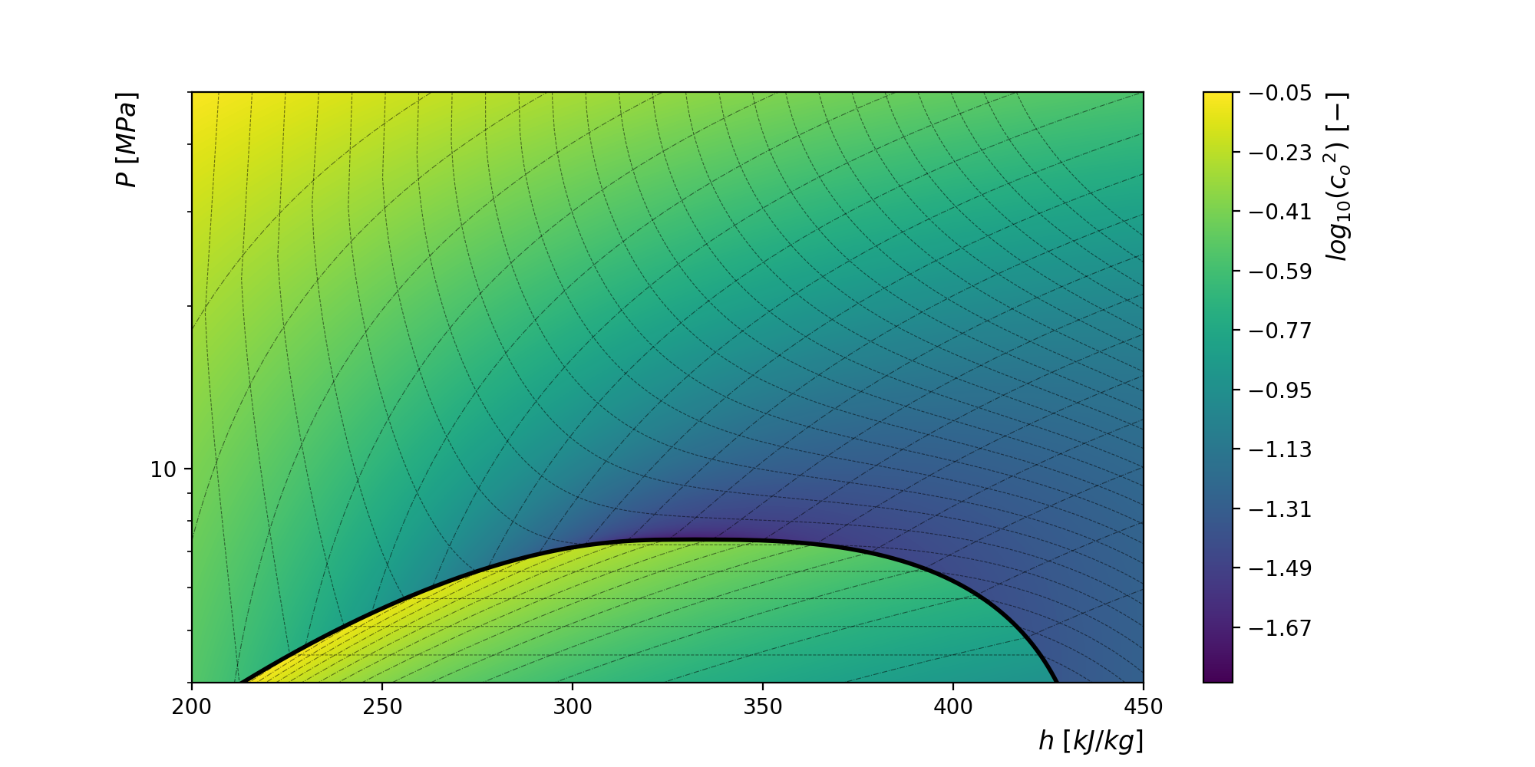

Figure A‑1 – local ${c_{0}}^{2}$ values for CO2 on a P-H diagram. Values are the evaluated using equation (A-8) for an adiabatic streamline ($d\dot{q}=0$). REFPROP has been used for property identification. Temperature and density isolines have been shown as well.

To deal with this effect, equation (A-4) is evaluated considering a mean value of ${c_{0}}^{2}$:

|  |  |
| --- | --- |
| ${c_{0}}^{2}= {\left({{c_{0}}^{2}}_{out}+ {{c_{0}}^{2}}_{in}\right)}/2$ | (A‑9) |

Were ${{c_{0}}^{2}}_{in}$ and ${{c_{0}}^{2}}_{out}$ are the evaluation of ${c_{0}}^{2}$ in the input and output point of the ascending/descending section. This makes equation (A-4) implicit ( ${{c_{0}}^{2}}_{out}$ depends on the value of ${c_{0}}^{2}$). Hence, it is solved iteratively using the procedure described in Figure (A-2).

Using the implicit definition for ${c_{0}}^{2}$ drastically reduces the error in $∆P$. This is evident by comparing the two areas shown in Figure (A-3), which represent the overall error and that partially cancels out. The procedure shown in Figure (A-2) allows calculation of $∆p$ for well deep up to 5km with a maximum error of about 2% compared with the direct solution of the integral. This uncertainty quickly approaches 0 as the depth of the well decrease.

Explicit formulation (with ${c_{0}}^{2}$ evaluated only at the inlet section) can be used as well but its accuracy drops for deeper wells. In this case well discretization could be needed.

The model described has been validated with result published by Adams et Al. [19], following the approach described by Schifflechner et Al. [28]. Validation results are presented in figure A-4.

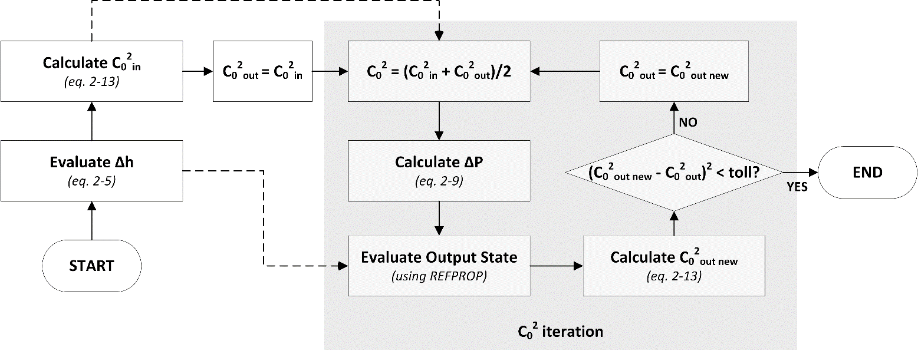

Figure A‑2 - ${c_{0}}^{2}$ iteration procedure. The procedure usually converges after a few iterations (less than 5)

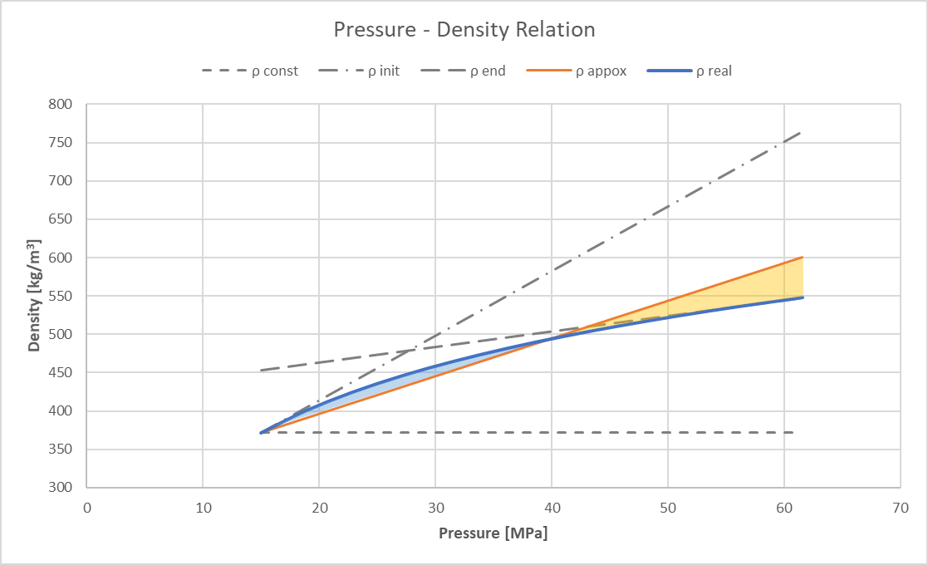

Figure A‑3 - Pressure Density Relation on a particular streamline (10km depth adiabatic well): The figure shows different linear relations that can approximate the pressure-density curve. The orange line is the implicit formulation from equation (A‑9)

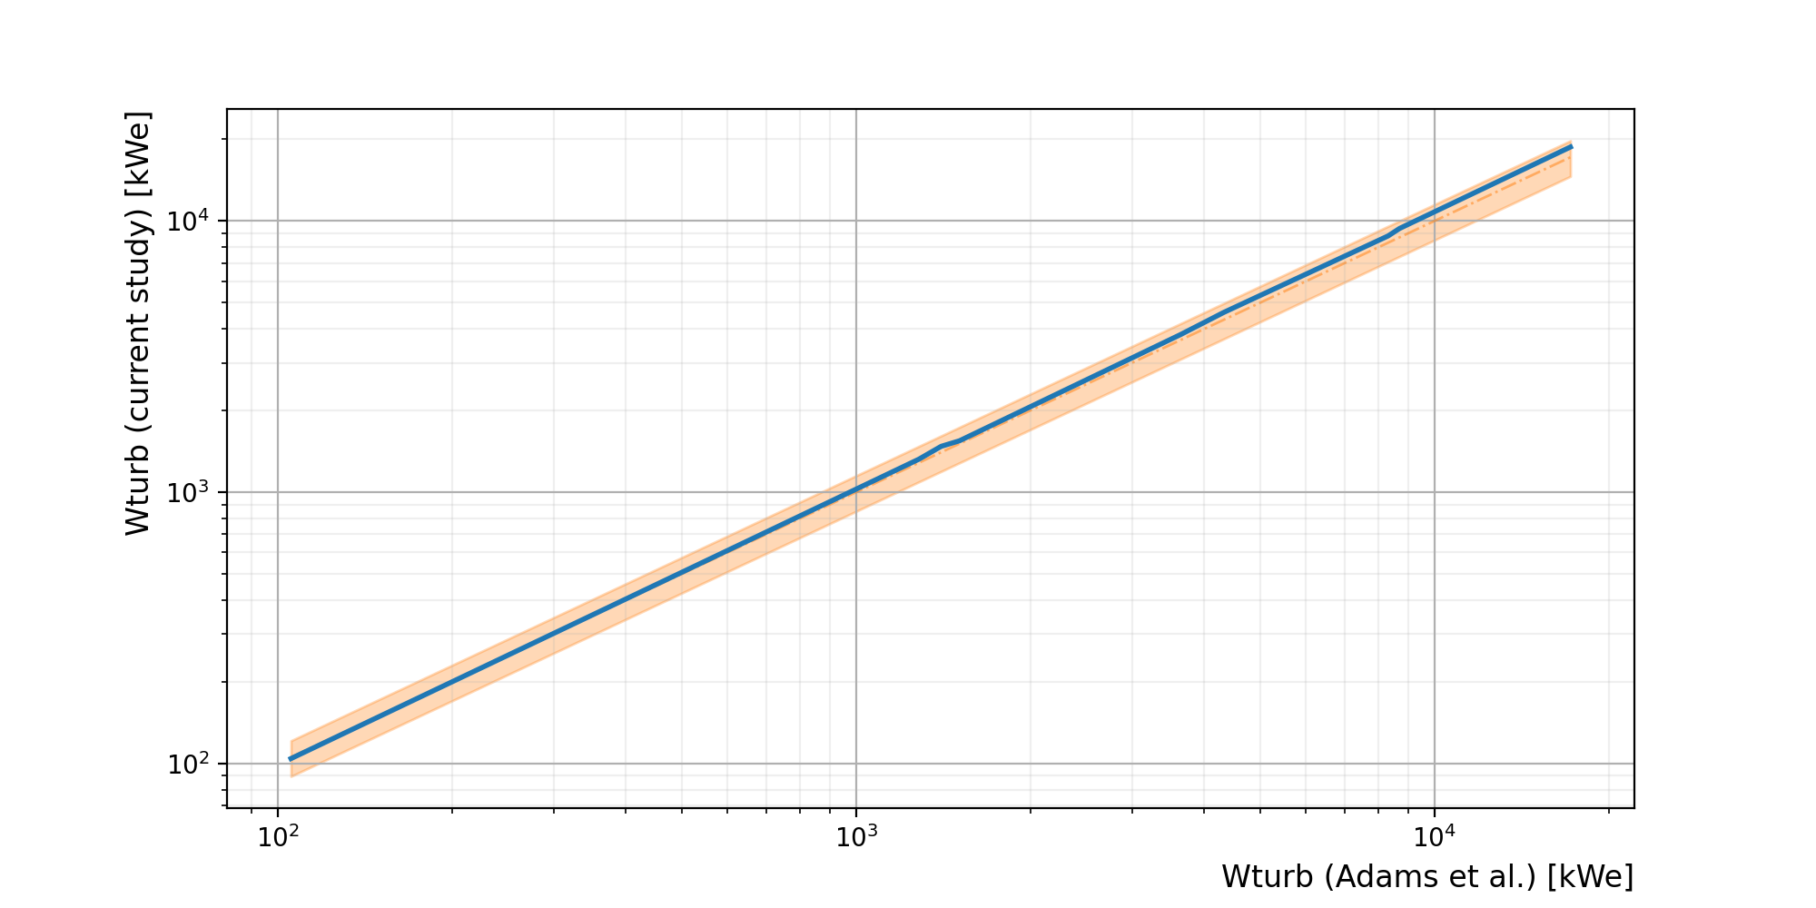

Figure A‑4 – Model Validation: comparison of current study model result with result published by Adams et al. [17]. Orange area represent a 10% error band.